**Who is in God’s Kingdom?**

**Reading:** Matthew 13:31-33

Then Jesus told the people another story:

“God’s kingdom is like a mustard seed that a man plants in his field. It is the smallest of all seeds. But when it grows, it is the largest of all garden plants. It becomes a tree big enough for birds to come and make nests in its branches.”

Then Jesus told them another story:

God’s kingdom is like yeast that a woman mixes into a big bowl of flour to make bread. The yeast makes all the dough rise.”

**Thought about the reading**

The stories that Jesus told in the reading are about things growing. The first story is about a tiny seed that grows into a huge tree where birds can nest. The second story is about a woman making bread. When I make bread in my bread-maker, I add one small teaspoon of yeast to the flour. The yeast makes the dough grow so that I end up with a lovely soft loaf of bread.

Jesus said that God’s kingdom grows like the mustard seed and the dough. It started very small, but keeps on getting bigger. It started with one person – Jesus. Then Jesus called 12 special friends. Other people joined them. When the Holy Spirit came down at Pentecost, there were 120 people. That same day, 3000 people decided to follow Jesus. The kingdom was growing!

Today God’s kingdom is everywhere. There are people following Jesus all over the world. It will continue to grow until it fills the earth.

**Prayer**

Lord Jesus, thank you that your kingdom started with one person, but it is growing and getting bigger all the time. Thank you that if I choose to follow you, I am part of that Kingdom.

Amen

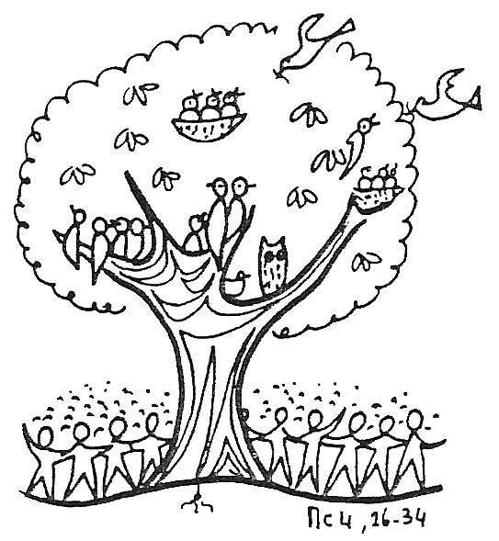

**Cambridge Causeway**

Spring 2023

Bible Study notes

**The Kingdom of God**

**3. God’s kingdom grows**

By Chrissy Cole